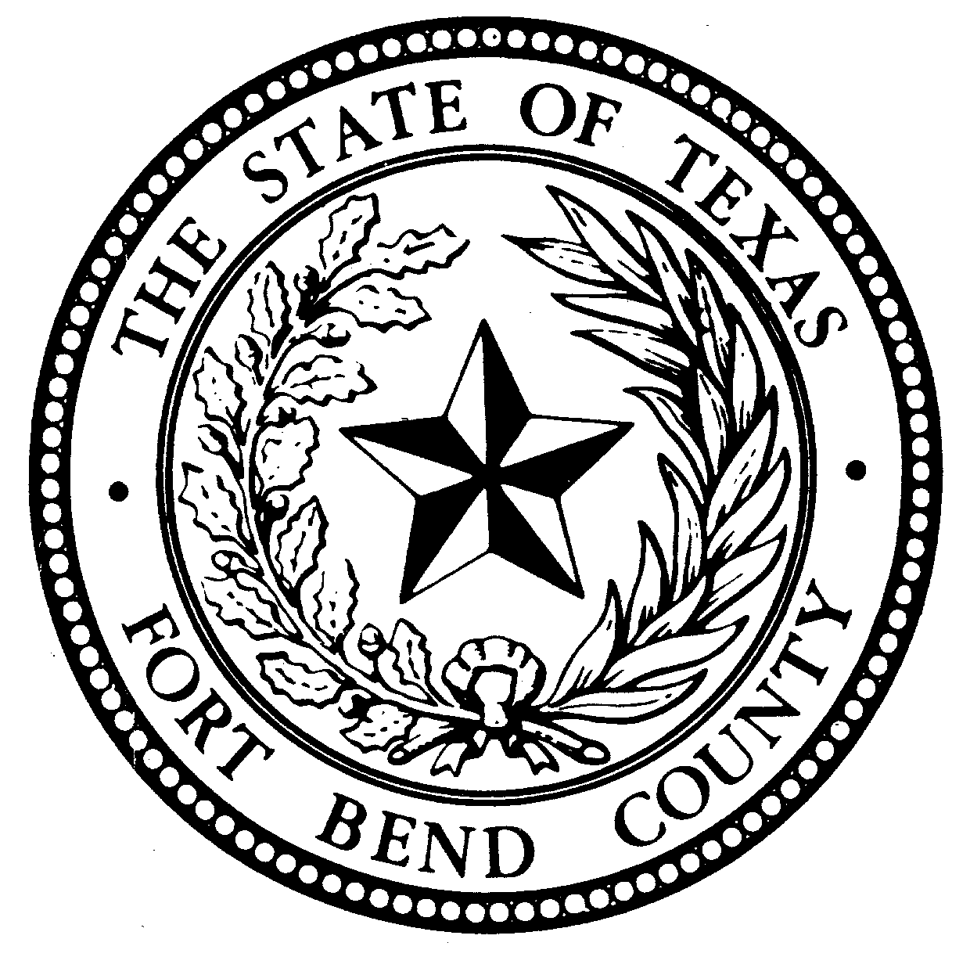

CONSTABLE'S
NOTICE OF SALE

Notice is hereby given, that by virtue of a certain Order of Sale issued by the clerk of the 434th District Court of Fort Bend County, Texas on April 26, 2022 in cause numbered 20-DCV-277797 styled GRAND LAKES COMMUNITY ASSOCIATION,INC.. vs. NJOKU ANASI AND ADA OTUKA ANASI in which a judgment was rendered on JUNE 15, 2021, in favor of GRAND LAKES COMMUNITY ASSOCIATION, INC.. for Eleven-Thousand-Seven-Hundred-Seventy-Two Dollars and Fifty-Five Cents ($11772.55); plus fees for posting notice of sale, publishing, costs of suit rendered by the court, legal fees, and all costs of executing this Writ.
I have levied upon the below listed property on May 2, 2022 and will on July 05, 2022 Tuesday, between the hours of 10:00 a.m. and 4:00 p.m. proceed to sell for cash to the highest bidder, all the Right, Title, and Interest of NJOKU ANASI AND ADA OTUKA ANASI to and in the following described Real Property

PROPERTY DESCRIPTION: LOT THIRTY (30), IN BLOCK TWO (2), OF GRAND LAKES, SECTION TEN (10), AN ADDITION IN FORT BEND COUNTY, TEXAS, ACCORDING TO THE MAP OR PLAT THEREOF, RECORDED IN SLIDE NO. 1926/A OF THE PLAT RECORDS OF FORT BEND COUNTY, TEXAS, MORE COMMONLY KNOWN AS 22707 EMILY PARK LANE,KATY TX 77494
The above sale to be made by me to satisfy the above described judgment in favor of GRAND LAKES COMMUNITY ASSOCIATION, INC. Plaintiff, and the proceeds applied to the satisfaction thereof.

LOCATION: FORT BEND COUNTY FAIRGROUNDS BUILDING C
4310 Highway 36 South
Rosenberg, TX 77471
DATE: July 05, 2022
TIME: APPROX. 10:00 am
BY: SERGEANT M. KUTACH
Chad Norvell
Constable Pct. 1
Fort Bend County, Texas

