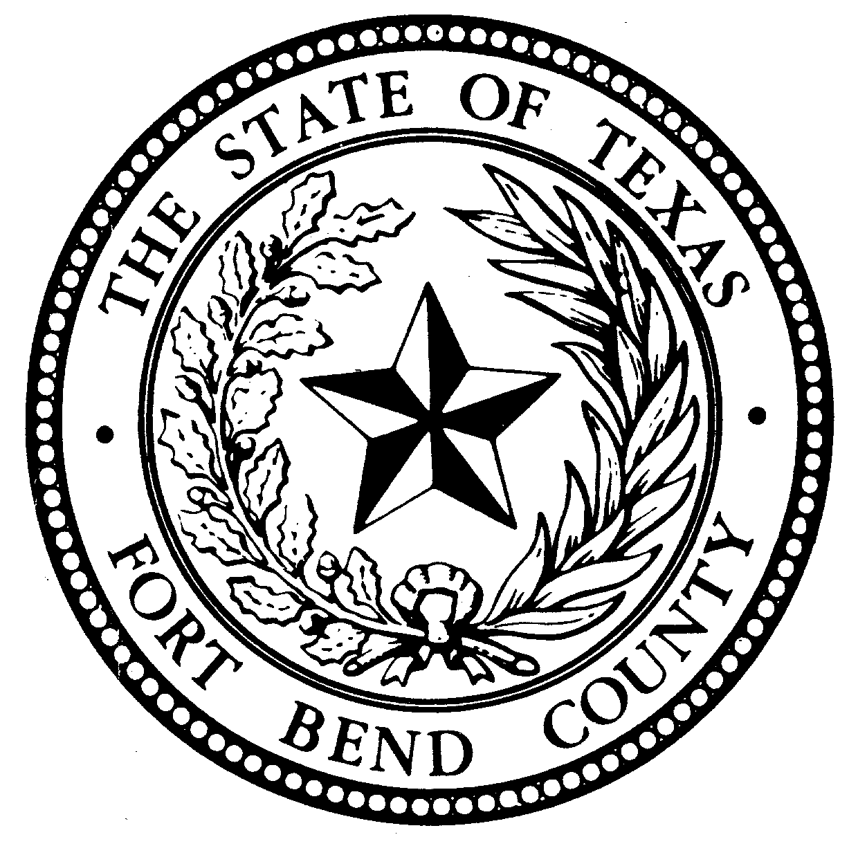

CONSTABLE'S
NOTICE OF SALE

Notice is hereby given, that by virtue of a certain Order of Sale issued by the clerk of the County Court at Law 6 of Fort Bend County, Texas on August 5 , 2020 in cause numbered 19-CCV-065456 styled SETTLERS PARK HOMEOWNERS ASSOCIATION vs. MARION J. MITCHELL, in which a judgment was rendered on Feb 14, 2020 in favor of SETTLERS PARK HOMEOWNERS ASSOCIATION for the sum of Two Thousand Six Hundred Ninety-Five Dollars and Eighty Three Cents ($2695.83); plus fees for posting notice of sale, publishing, costs of suit rendered by the court, legal fees, and all costs of executing this Writ.

I have levied upon the below listed property on August 14, 2020 and will on Oct 6, 2020Tuesday, between the hours of 10:00 a.m. and 4:00 p.m. proceed to sell for cash to the highest bidder, all the Right, Title, and Interest of MARION J. MITCHELL to and in the following described Real Property

LOT THREE(3),IN BLOCK NINE(9), OF SETTLERS PARK,SECTION ONE(1) AN ADDITION IN FORT BEND COUNTY, TEXAS,ACCORDING TO THE MAP OR PLAT THEREOF RECORDED IN in volume 20, page 12 OF THE PLAT RECORDS OF FORT BEND COUNTY, TEXAS, commonly known as 3010 MOSBY DR SUGAR LAND, TX 77479
The above sale to be made by me to satisfy the above described judgment in favor of SETTLERS PARK HOMEOWNERS ASSOCIATION Plaintiff, and the proceeds applied to the satisfaction thereof.

LOCATION: FORT BEND COUNTY TRAVIS BLDG 1^{ST FLR}
MEETING ROOM 301 JACKSON
RICHMOND, TX 77469
DATE: Oct 6, 2020
TIME: APPROX. 11:00 am
BY: SERGEANT M. KUTACH
TREVER J. NEHLS
Constable Pct. 4
Fort Bend County, Texas

